*Contact with your Spirit and Soul*

*In Greece*

**Holidays Plus** Dance & Music

Summer Tour

KYTHNOS island

**20 Jun – 01 Jul 2019 (12 days**)

*Nature and humans in harmony*

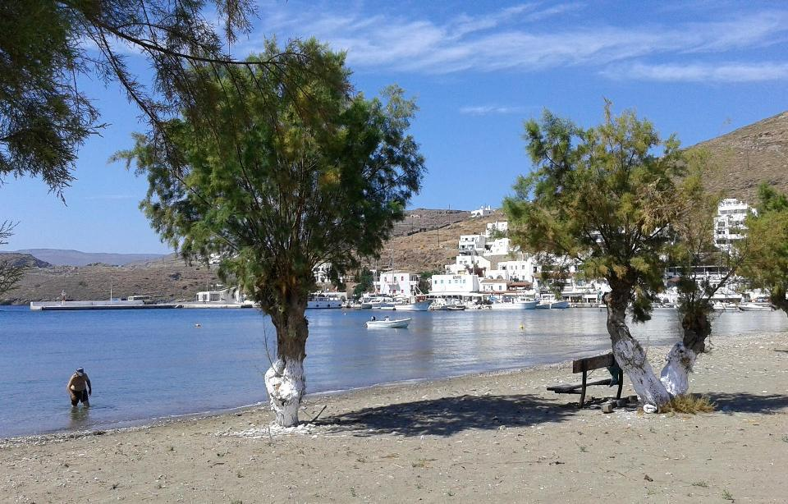

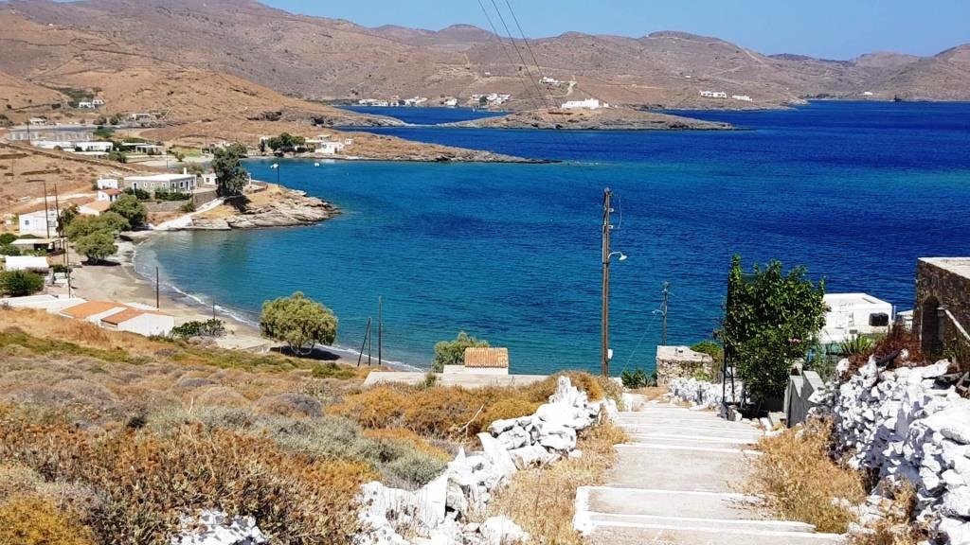

One of the few places that landscape and humans are so fitted together for 10.000 years and still managing to reflect their relationship in every step or dive.

No words can describe the feeling you get when Kythnos opens up to embrace you with its purity of nature and hospitality. You just have to be there.

On this island I selected a very hospitable (“philoxeno” in Greek) hotel and exciting tours in order to give you the maximum of experience in joy, sightseeing, culture and unique moments



Excursions to:

* Athens- Cape Sounio : To visit Poseidon’s temple

(Entrance fees not included)

* Villages and the main town of Kythnos
* Boat trip to Kolona where the land splits the sea into 2 parts (photo)

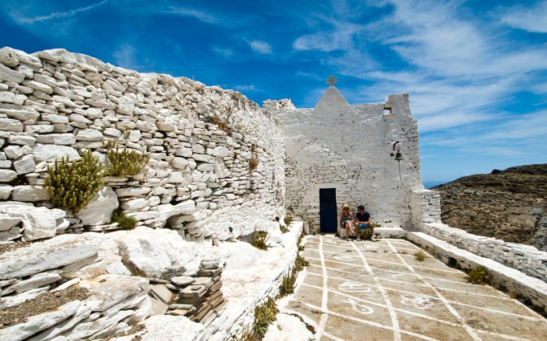

The price of the tour includes:

* All bus, boat and excursion transfers + boat trip to Kolona
* Hotel in double room with breakfasts
* Dinners (Lunches - Drinks not included)
* Taxes (Hotel taxes not included)
* 2 ½ hours/day course Greek dancing
* ½ hour/day course in Greek language
* 1 hour/day course in Greek singing
* Feast with 4 top musicians brought from Athens + local musicians

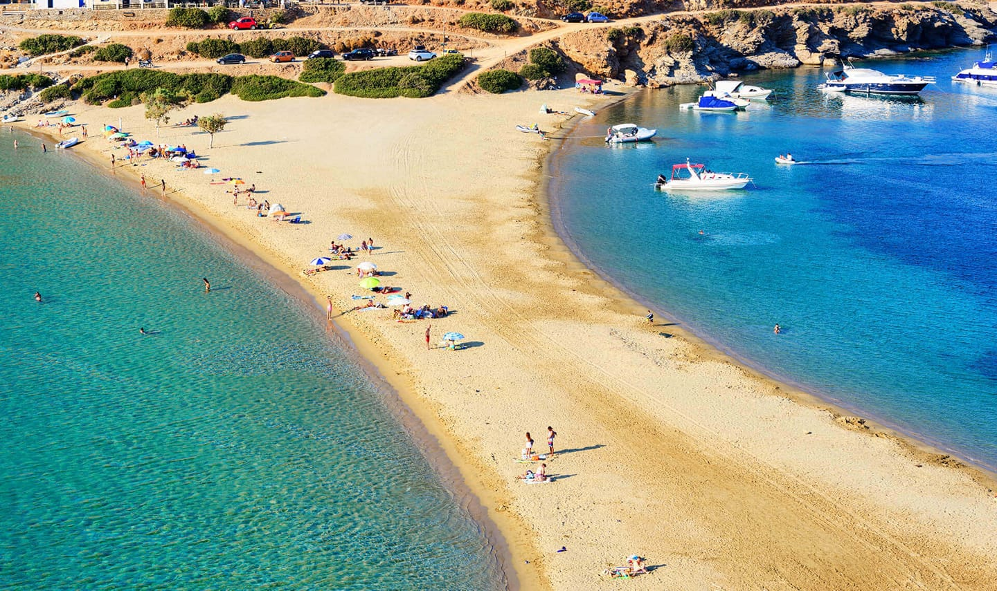

Price

* The price is 1,570 € (single room extra 350 € )
* Given the limited number of rooms at this workshop, registrations will be accepted on a first come, first served basis.
* *Please also check the Terms provided in the Daily Program leaflet.*

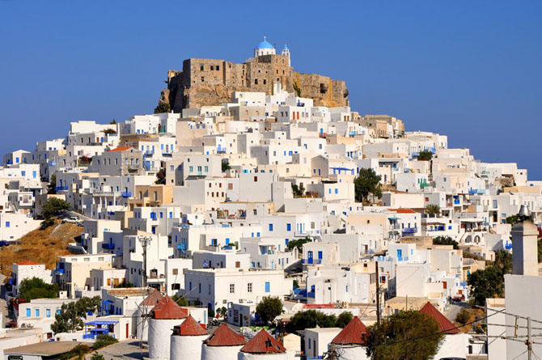

Every year since 1994, we do have a wonderful time together, with lots of fun, while learning about Greek culture in some of the most beautiful parts of this magical country. **Don’t miss KYTHNOS 2019!**

**Panayiotis Mavropoulos** Dance Instructor-Musician – Seminar & Tour organizer since 1994

For information or to register (deposit 300 euro by 20 January 2019) please contact

**Panayiotis Mavropoulos Aud Jorunn Bergsvik**

[panayiotis.mavropoulos@gmail.com](mailto:panayiotis.mavropoulos@gmail.com) audjorunn@gmail.com Tlf: 924 64 334